UNITED WAY OF SOUTHERN KENTUCKY
COMMUNITY IMPACT PLATFORM

EDUCATION – Prepare children, youth & young adults to succeed in school and life (cradle to career)

Priority Focus Area: Kindergarten Readiness – Children start school at levels of physical, social-emotional and intellectual development needed for school success.

BIG, BOLD GOAL: Increase BRADD area kindergarten readiness scores from 49.4 % to 75% by 2020.

Strategies:
- Improve early learning environments and increase access to high quality licensed child care programs for children and families, particularly those of low-income and educational risk.
- Increase early learning opportunities, including early literacy and language development.
- Provide resources, education and other needed supports for families and caregivers to bolster their child’s age-appropriate development.
- Collaborate to create and implement a comprehensive high quality approach to school readiness.

Priority Focus Area: College & Career Readiness – Students graduate high school prepared for college or other post-secondary training, work and life.

BIG, BOLD GOAL: Increase BRADD area college & career readiness scores from 65 % to 80% by 2020.

Strategies:
- Improve the connection between school and work for disconnected youth through career and technical education, apprenticeships, work study and other innovative education approaches.
- Increase the availability and use of postsecondary assessment tools.
- Provide quality out-of-school opportunities that reinforce and enhance learning and preparation for future success.
- Increase the preparation and soft skill development of students for post-secondary opportunities/choices.

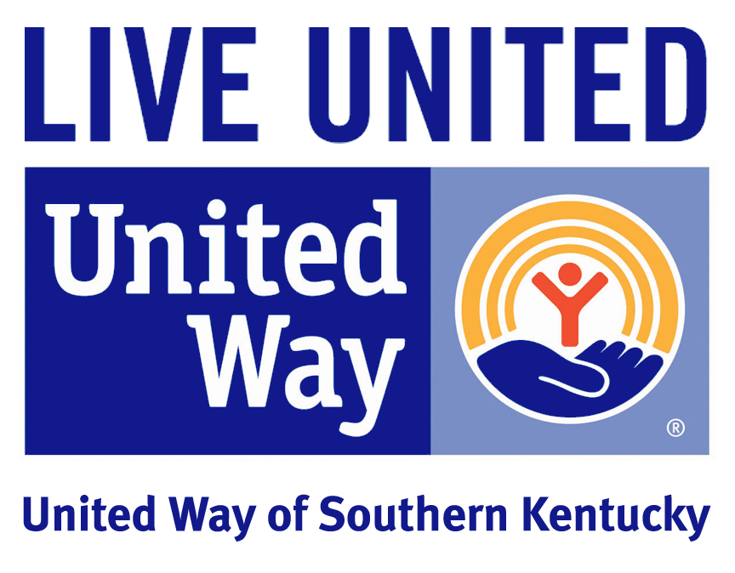

INCOME – People have the appropriate skills to maintain a living wage employment.

Priority Focus Area: Workforce Development – Individuals have the training and skills needed to obtain and maintain family-sustaining employment.

Strategies:
- Increase/create employment opportunities for individuals with felony records through training/reengagement in education, educating employers and connection with services to help secure employment.
- Provide support and education on training/post-secondary programs for individuals that have graduated high school but have not moved on to post-secondary programs and/or do not have sustaining employment.
- Provide opportunities for individuals that are under-employed to access employment matching their skill set.
- Increase knowledge of, and access to, training and education opportunities for unemployed individuals with focus on returning them to the active workforce.

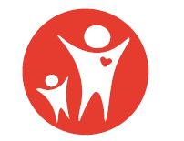
HEALTH – Increase access to quality, affordable health and crisis intervention services.

Priority Focus Area: Access to Affordable Health Care – Individuals have access to affordable, preventative, physical, mental, dental and other needed care critical to good health.

Strategies:
- Increase the number of eligible individuals that are enrolled in viable health care coverage options.
- Increase the number of qualified professionals and patient access for medical care needs including underserved needs like mental health, prenatal care, dental care and substance abuse treatment.
- Provide education programs designed to improve long-term health including navigating the health care system, substance abuse prevention, mental health, wellness, smoking cessation and obesity reduction/prevention.

Priority Focus Area: Safe Home and Community – People are safe from violence, crime, emotional and physical abuse.

Strategies:
- Reduce the impact of violence on individuals and families through safe and accessible emergency shelter and crisis services.
- Provide education programs to reduce the incidence and impact of family and individual violence including violence prevention, parenting education and public awareness.

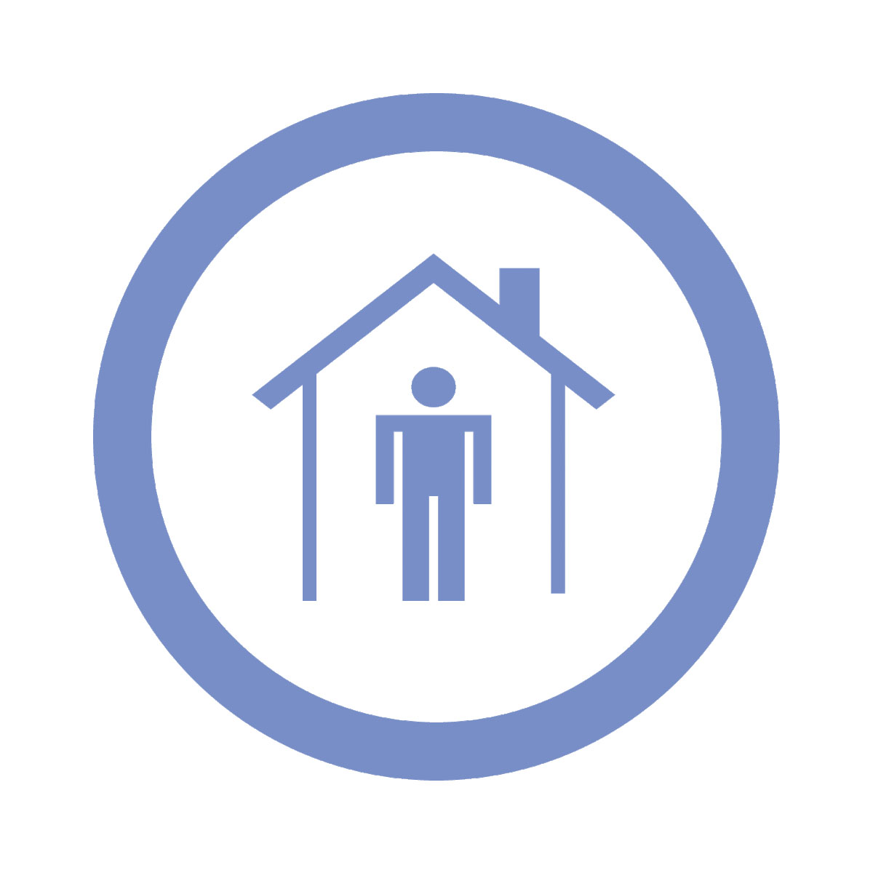
SAFETY NET – Basic needs are met in a timely manner through a coordinated system of resources.

Priority Focus Area: Access to Basic Needs – Basic needs of food, clothing, and safe and affordable housing are met.

Strategies:
Emergency Assistance
- Provide emergency assistance (food, clothing, shelter, furnishings, utility assistance) to individuals who are homeless or in a financial crisis, incorporating efforts to return the individual to self-sufficiency.
Housing
- Increase rental housing sustainability supports including financial assistance for low-income (200% of poverty and below) households, and consumer education opportunities for financial literacy and renter/landlord rights & responsibilities.
- Increase the availability, and consumer knowledge of availability, of safe, affordable and habitable housing.
- Decrease total housing costs for low-income households through improved energy efficiency of dwellings.
Food
- Provide options for healthy and affordable food choices that include nutrition and healthy meal planning education, with focus on reducing both food deserts and service duplication.
Clothing
- Increase options and access for work related apparel and accessories.

Priority Focus Area: Transportation – Multiple options for safe and reliable transportation are available.

Strategies:
- Increase viable transportation options across our communities including, but not limited to, volunteer driver programs, access to low-cost vehicles and/or car loans and alternative, environmentally friendly modes such as bicycles and mopeds.
- Provide financial supports for low-income (200% of poverty and below) households to access current mass transit routes.

