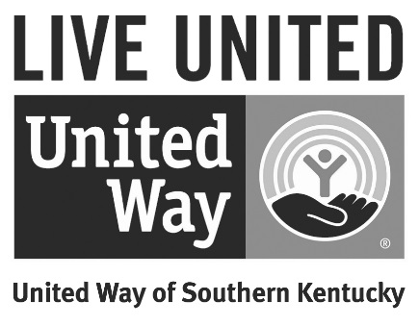
2019 LIVE UNITED AWARD APPLICATION

Please complete the following application completely to be considered for the 2019 LIVE UNITED Award. Please only list United Way specific activities. While efforts towards all non-profits in our community are greatly appreciated, they will not be considered in the judging for the 2019 LIVE UNITED Award.

The Live United Award is United Way of Southern Kentucky’s top award that is presented annually to the organization that exemplifies United Way’s core give, advocate and volunteer goals through:
  - Outstanding campaign support including increased giving, high participation and per capita (organization MUST have had an increase in giving in the 2019/20 campaign)
  - Advocating internally and externally on behalf of United Way and Education (emphasis on Early Childhood Education), Income, Health and/or Safety Net issues and/or 2-1-1 throughout the year
  - Exceptional volunteer participation from a large base of employees in the areas mentioned above

A committee of judges will review all applications and select 3 finalists which will be featured via video at the 2019/20 LIVE UNITED Awards & Annual Meeting event which will be held February 4th, from 5pm – 7pm. The LIVE UNITED award winner will be announced during this event.
Please email completed application to: enewbold@uwsk.org by December 4th. Please include photos and other supporting materials as warranted and be as specific as possible regarding your activities/support in each area.

Company Name: _________________________ Contact Name: ________________________

Phone Number: __________________________ Email: _______________________________

Please complete the following statements (3 – 5 sentences):

My organization helped to move the needle in United Way’s work in Education, Income, Health and Safety Net issues by….

My organization deserves to win the LIVE UNITED Award because….

VOLUNTEER
Did your company employees volunteer for/ participate in:
Board of Directors Y N
Executive Committee Y N

Volunteer Committee Y N
Number of volunteers:

Community Impact Committees Y N
Number of volunteers:

Campaign Cabinets Y N
Number of volunteers:

Allocations Teams Y N
Number of volunteers:

Feed the Need Y N
Approximate number of items collected:

Handbags for Hope Y N
Committee members:
Items donated with value:
Number of attendees:

Day of Caring Y N
Number of volunteers:
Number of projects completed:
Issues impacted (circle all that apply): EDUCATION INCOME HEALTH SAFETY NET

WKU LIVE UNITED White Out Y N
Number of volunteers:
Amount donated:

Other (ex. 2-1-1, Kindergarten Readiness):
Please list (attach additional page if needed):

Total approximate number of volunteers: _________________

ADVOCATE
In kind support (approximate value): ____________________
Please list (attach additional page if needed):

Internal advocacy efforts (promotion of United Way via company’s website, intranet, mass e-mail company newsletter articles, etc.) – special consideration given to those which promote work in Education, Income, Health or Safety Net and 2-1-1:
Please list (attach additional page if needed):

External advocacy efforts (employees speak on behalf of UW, helped create new avenues for support, etc.) – special consideration given to those which promote work in Education, Income, Health or Safety Net and 2-1-1:
Please list (attach additional page if needed):

GIVE
2019/20 Campaign Results (contact enewbould@uwsk.org to confirm totals if needed- leave blank if you aren’t sure):
Corporate Gift: __________________ Amount of increase: _________________
Employee Gift: __________________ Amount of increase: _________________ % Participation: _________
Special Events: __________________ Please list (attach additional page if needed):

TOTAL 2018/19 CAMPAIGN: ___________________TOTAL INCREASE: __________________

Additional Impact Initiative Gifts in Education, Income, Health, and/or Safety Net (ex. Dolly Parton Imagination Library, Kindergarten Readiness) and/ or 2-1-1: __________________________________
Please list (attach additional page if needed):

Sponsorships (cash): _______________
Please list (attach additional page if needed):

Other: _________________
Please list (attach additional page if needed):

OTHER:
Please list any other United Way specific activities that your organization contributed to in 2018 that were not listed above (Please provide applicable specifics for each activity including number of participants, results - dollars raised, books or cans collected, etc.). Please note specific activities that impacted Education, Income, Health and/or Safety Net issues. Attach additional page if needed.

